Q1 Simple linear regression

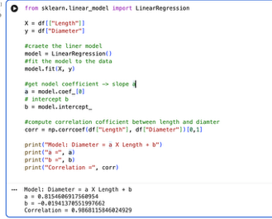
Model obtained
The fitted linear model is Diamter = 0.8155*Length - 0.0194
The correlation cofficient between Length and Diamter is r=0.98681

Interpretation
- The correlation coefficient is very high (≈0.99) meaning that there's almost an exact linear relationship between length and diameter.
- The insignificant negative intercept is biologically irrelevant (an abalone cannot have a negative diameter), is not the sum of errors but stands for measurement noise and indicates that the regression line has been optimized along non-zero lengths.

Conclusion
The regression coefficients show that abalone shell size can be predicted from length alone. This tight linear correlation aligns with the morphological character definitions included in the dataset documentation.

Q2 Multilinear model

1) Calculating the sum of the three component weights
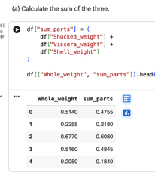
Computed the sum of shucked weight, viscera weight, and shell weight for each abalone
specimen sum_parts=Shucked_weight+ Viscera_weight+Shell_weight

2) Correlation between Whole weight and the sum of its components
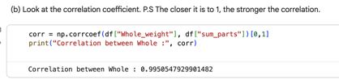
The correlation coefficient is r=0.99505
This indicates an extremely strong linear relationship.
The closer to 1, the stronger the correlation.

3) Difference between Whole and the sum of parts
To examine whether whole weight is exactly equal to the sum, we computed: diff=WholeWeight−sumparts
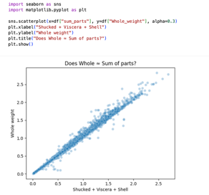
The summary statistics for this difference are Notable observations: Mean difference ≈ 0.050 grams / Standard deviation ≈ 0.058 grams / Minimum = –0.4475, Maximum = 0.6080 Whole weight is consistently slightly larger than sum_parts

4) Scatter plot of Whole_weight vs sum_parts

Regression Model
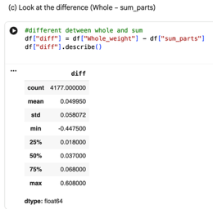
The multilinear regression model
Whole_weight=0.9366⋅Shucked_weight+1.1116⋅Viscera_weight
+1.2530⋅Shell_weight−0.00783

Interpretation of coefficients
The coefficients are not 1 exactly meaning that the components do not equally contribute. The shell weight coefficient is also the largest (1.253), indicating increasing weight of shells will lead to an increase in total weights, perhaps because there's a relationship between shell weight and overall abalone size.

Conclusion
The total value of the predictor sums is very nearly equal to 100%. Weight is very strongly (0.995) correlated with the sum of its parts. However, the coefficients in the regression model differ from 1, and the whole weight is slightly greater than the sum of the dried/measured components, indicating measurement differences and biological variation.

Q3 Relationship between the whole weight and diameter

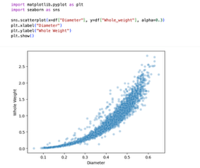
Show plot of the relationship
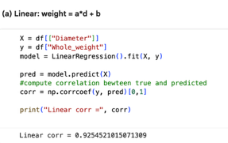
The plot shows a clear non-linear, upward-curving pattern. Weight increases slowly for smaller abalones and much more rapidly for larger ones, indicating that a linear model is unlikely to capture the full curvature of the relationship.

(a) A simple linear model
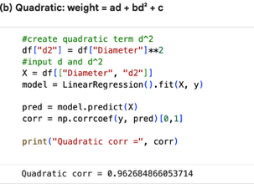
Weight = a *diameter +b
Line Correlation : r = 0.92545 $$

(b) A quadratic model
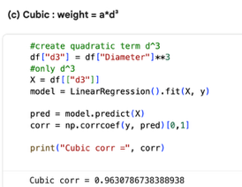
Weight=a⋅ diameter +b⋅ diameter^2+c
Quadratic Correlation : r = 0.96268

(c) A cubic model without lower order or constant terms
Weight=a⋅ diameter ^3
Cubic Correlation : r = 0.96307

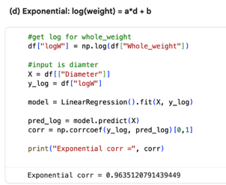
(d) An exponential model
log (weight)= a⋅ diameter+b
Exponential Correlation : r = 0.96351

Model comparison
Model | Correlation | Performance
Linear | 0.92545 | Poor/ underfits curvature
Quadratic | 0.96268 | Good/ captures curvature
Cubic (d³ only) | 0.96308 | Good/ slightly better than quadratic
Exponential (log-linear) | 0.96351 | Best/ simplest with highest r

Final choice
log(Weight) = a *diameter +b

Q4 Logistic Regression

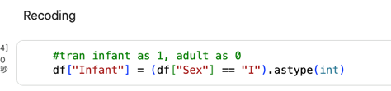
Recoding the target variable
We convert the class label into a binary attribute Infant (I) → 1 Adult (M or F) → 0

(a) Using Length only
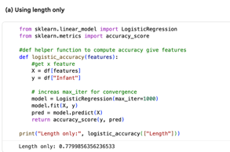
Accuracy = 0.77999
Size only gives fair prediction performance. This reflects the fact that infants are usually smaller. But adults can be of different length and thus this feature is an imperfect one for distinguishing them.

(b) Using Whole weight only
Accuracy= 0.79555
Whole weight has slightly better predictive value than length. This is not surprising, as babies have much smaller total body mass and therefore weight is a more efficient discriminating measure.

(c) Using Rings only
Accuracy = 0.78813
Rings indicate the number of shell rings. Cup age is a very natural predictor given that rings + 1.5 = age and indeed there are fewer rings from noisier pictures as predcited from the children in relation to infants example.

(d) Using Length + Whole weight + Rings (combined model)
Accuracy = 0.81398
This is the best-performing model among the four. Each feature contributes complementary information
Length → physical size / Whole weight → body mass / Rings → biological age

Conclusion
Whole weight is the best performing on single attribute, reflecting that infants have much smaller weight comparing to an adult. The concatenated model (Length + Whole weight + Rings) achieves the best accuracy at 81.4%, indicating that abalone infant classification is improved when both size and mass as well as relative age-related attributes are used.

Q5 Logistic Regression on the Adult Dataset

Read Data
The Adult dataset was loaded from the UCI repository. Missing values were removed. Categorical attributes were converted using one-hot encoding.
drop_first=True to avoid dummy-variable traps
The target variable was recoded as: Male = 1 / Female = 0
All one-hot–encoded features were used except the sex_Male column, which must be removed to avoid data leakage.

Logistic Regression Model and Accuracy
A logistic regression classifier was trained on the processed dataset:
Accuracy = 0.8081
This means the model correctly predicts an individual's sex about 80.8% of the time. A convergence warning occurred due to high dimensionality after one-hot encoding; increasing max_iter or scaling could improve numerical convergence but does not change the overall conclusion.

(a) Attribute Selection

Removing features without losing accuracy
By iteratively removing features and retraining, several attributes were found to have minimal impact on accuracy (≤1% change)
Attributes removable with almost no accuracy drop
Fnlwgt / education-num/ capital-gain/ capital-loss/ native-country

Reason these can be removed
- fnlwgt, capital-gain and capital-loss show weak direct association with sex, and their information overlaps with other income-related features.
- education-num is a numeric encoding of education; keeping the categorical education variables and dropping education-num causes almost no loss.
- native-country is highly imbalanced (mostly “United States”), so it carries little information overall; very rare categories may create unstable coefficients.

(b) Why is relationship-status helpful?
relationship is one of the most predictive attributes in the dataset.
Examples:
- "Husband" → almost exclusively male / "Wife" → almost exclusively female
- "Own-child" → often female (single mothers)/ "Not-in-family" or "Unmarried" → more mixed
Gender roles are strongly represented as they correlate with gender categories in census data. As a result, the model attaches large weights to such categories, and greatly improves classification accuracy.

(c) Why is country=Holland weighted heavily?

Reason: extremely small sample size
In the Adult dataset:
There is only one individual from Holland
That individual happens to be male
So the logistic model sees: Holland⇒Male 100% becaues a very strong male indicator and predict close to 1

Conclusion
The full logistic regression model achieves ≈ 81% accuracy. Removing certain weak or redundant attributes maintains accuracy within 1%.
The most useful features include:
- relationship
- hours worked per week
- education level
- several occupation and workclass categories

